PERU
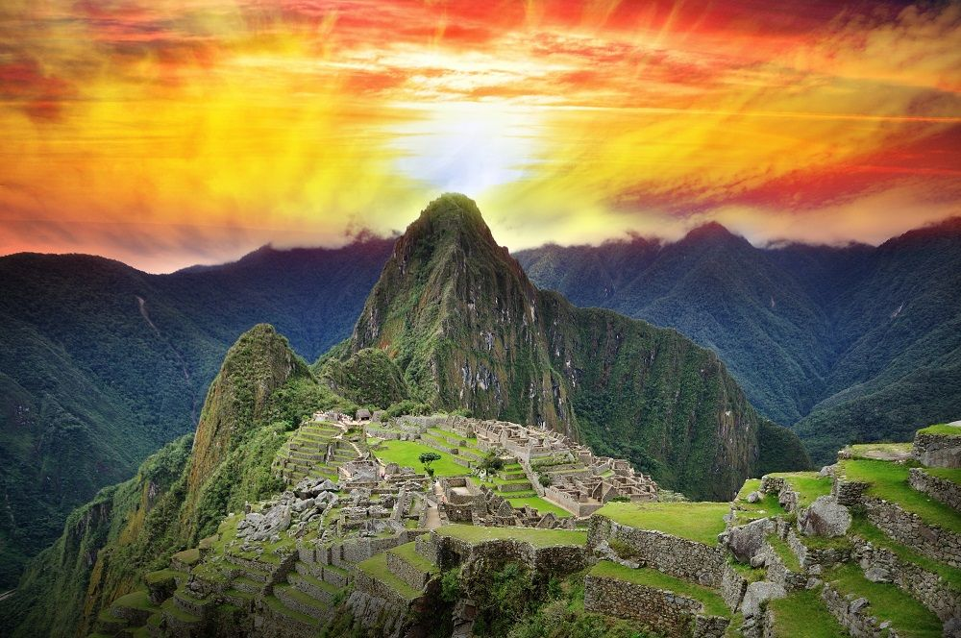
PLANT MEDICINE INTENSIVE

March 5th-11th 2021
Awakening begins, healing takes place
Immerse into the heart of the Andes through the power of Plant Medicine Wachuma. Dive deep into the ancient wisdom of healing through plant Medicine . Return to your true self as we uncover the healers with in on this 4 day 5 night plant medicine intensive we will be in nature, in Machupichu, and at Willkasara Retreat Center with plant medicine under the Guidance of Peruvian Medicine Family Wachan, Martika and Shiqwarkenty with 40+ plus years of experience healing with Wachuma opening hearts awakening spirits.

Through this journey we will be in ceremony, in prayer, meditating, chanting, dancing and healing with Grand Father Wachuma as our body minds and spirits open to the ancient wisdom that lives with in us and as us Heal your emotional body, mind and spirit .

WHO ARE THE WILLKASARA MEDICINE FAMILY ? Read our Bios at www.willkasara.org
Willkasara a family of medicine people of the Andes of Peru and Colombia, have been sharing their teachings and plant medicine work with the global spiritual community for over 45 years. Sharing their knowledge through conferences, workshops, retreats, and Plant Medicine Ceremonies.

Their Permanent home is the Sacred valley of the Incas, where they facilitate custom retreats to personalize your healing journey in the Sacred Land of the Inkas. The Willkasara medicine family's mission is to guide each person back to them selves and uncover the healer with in, in order to achieve that mission, first we must liberate our selves from trauma, addictions, losses and any obstacles that do not allow us to transcend and move forward in our spiritual growth.
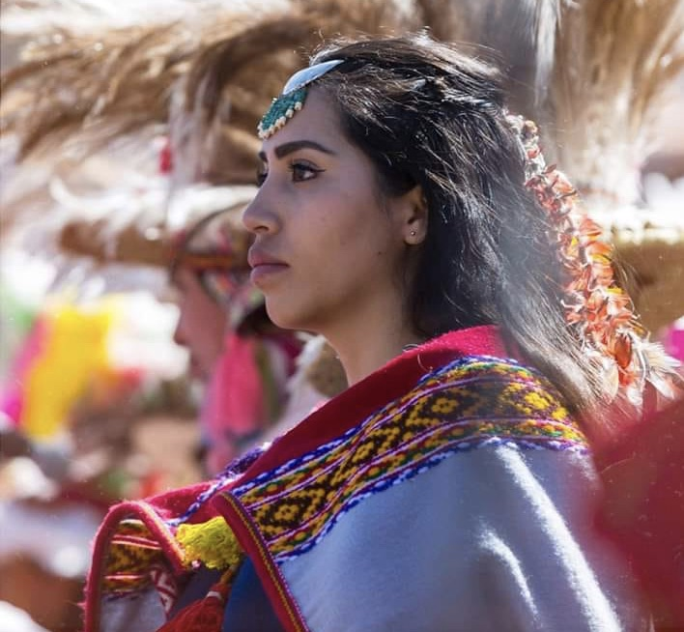
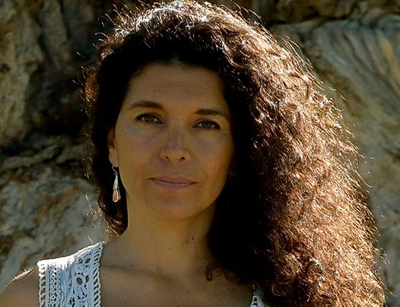
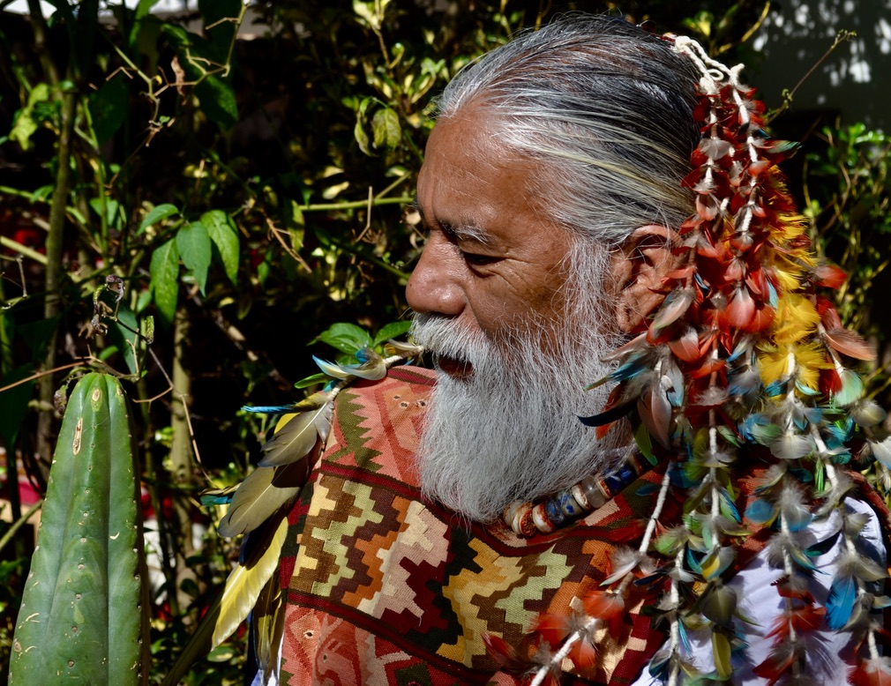
Willkasara dedicates their life's mission to helping individuals and families unlock the wisdom we hold within. Over the years they have been carrying their traditions and sacred ceremonies across the world to share with those who's hearts are open for transformation. This Medicine family from the Andes of Peru and Columbia primarily work with sound therapy and Plant Medicine to help us achieve the spiritual breakthroughs many of us are searching for in this life time, to reconnect with our selves and Mother Nature, heal our bodies, minds, and spirits as well as heal the past. step into the future.

Wachan Bajiyoperak Shiqwarkenty Bajiyoperak Martika Bajiyoperak

WACHUMA MASTER PLANT MEDICINE :
Wachuma is cactus form the Andes of Peru that has been used by Inka and Pre-Inka Civilizations for thousands of years to rise the collective consciousness of our societies and to connect Mankind with the spirit world.
Grandfather Wachuma is the key to the heavens, and to reawaken the heart of mankind
This Sacred Plant Medicine reconnects you with the universal beauty, brings harmony, joy, peace and balance into our lives. Many people with depression, anxiety, drug and alcohol abuse have recovered fully through Wachuma Ceremonies.

Wachan has over 40 years of experience leading and facilitating Wachuma Plant Medicine Ceremonies around the world and helping many people recover of their ailments through his teachings and ceremonies.

“Our ceremonies are very sacred, we prepare ourselves during our whole life time for this path to be a keeper of the sacred Medicines. We respect life and the Sacred Medicines, we are not experimenting with people. In the last 20 years Wachuma and Ayahuasca have become very popular around the world because of their healing powers, at the same time this popularity has revealed a group of people from around the world who are confusing and misleading our ancient ways of ceremony that has been passed down generation after generation here in the Andes, claiming they are “shamans”. These confused people are misusing the power of the sacred plants for their own greed. Love is not blind, love is wise.
My purpose and mission is to share with the world the magic and power of the Plant Medicine Wachuma in its authentic form in a safe and appropriate environment and to guide you into the magical and powerful land of the Andean Civilizations, Peru .

RETREAT ITINERARY

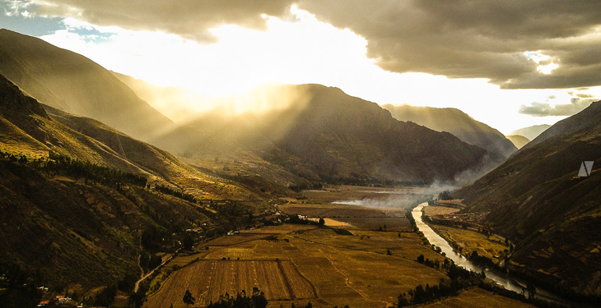
Day :1 Cusco Pumamarca, Opening Ceremony – Caicay (March 5th)
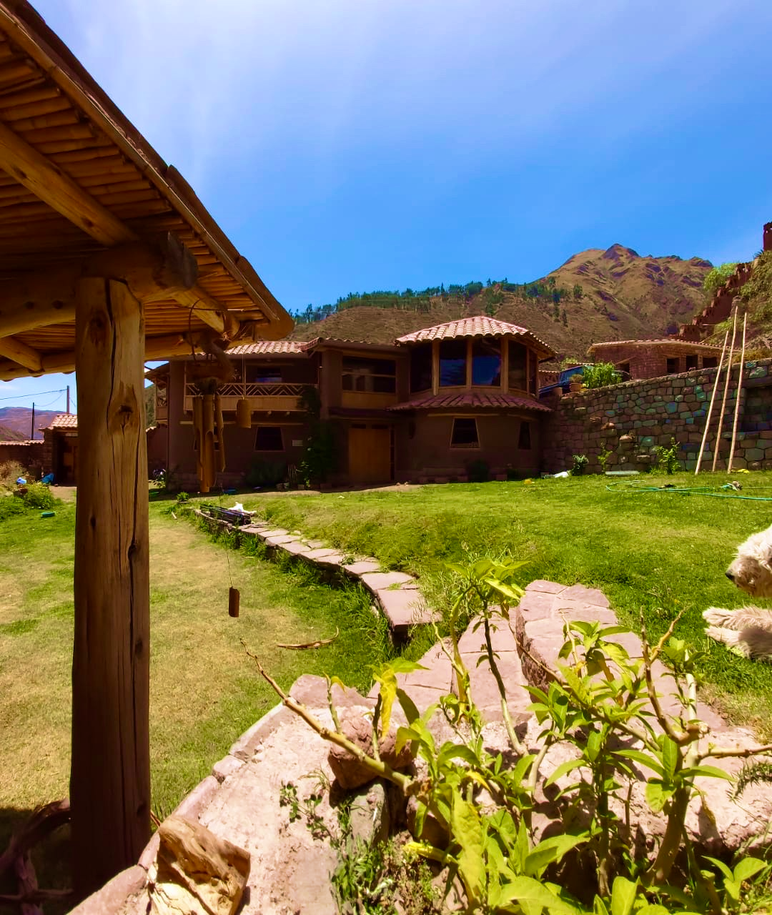
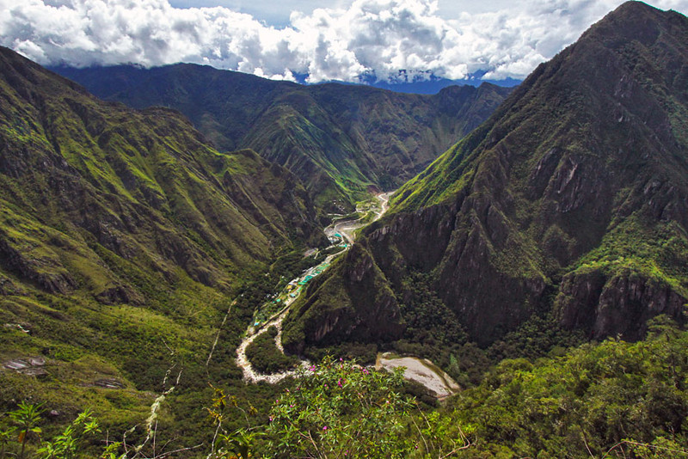

Upon you arrival on this magical Plant Medicine Intensive we will have our first ceremony with Pachamama (Mother Earth) to request permission for the pilgrimage of healing and transformation we are about to embark upon. We will then head out on a 40 minute drive to Caicay the “head” of ther Sacred Valley of the Inkas where you will be staying over the next few days at the Willkasara Retreat and wellness center.
Night at: Willkasara Retreat Center All Meals Included
All Meals Included

Day 2: Plant Medicine Ceremony Caicay Sound Healing – Ollantaytambo- Machu Pichu
( March 6th )
( Introduction to the Medicine World and the Andean ways of Healing , Welcoming Ceremony )
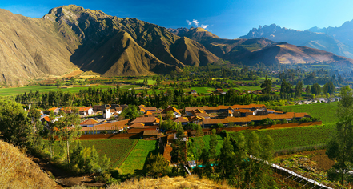
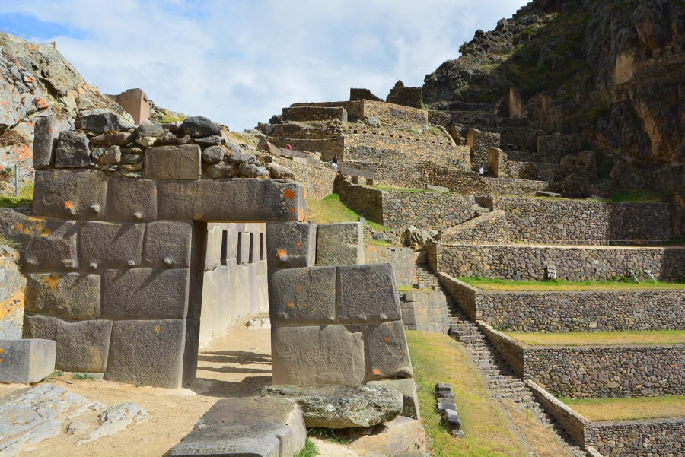
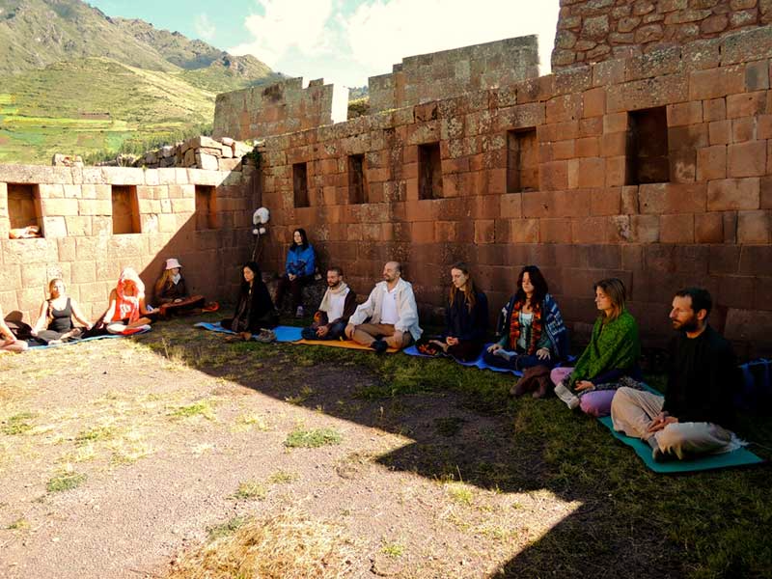

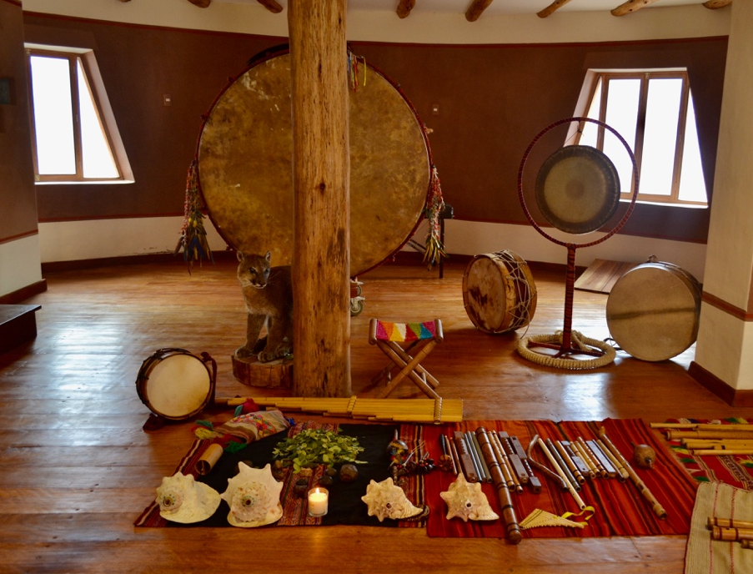
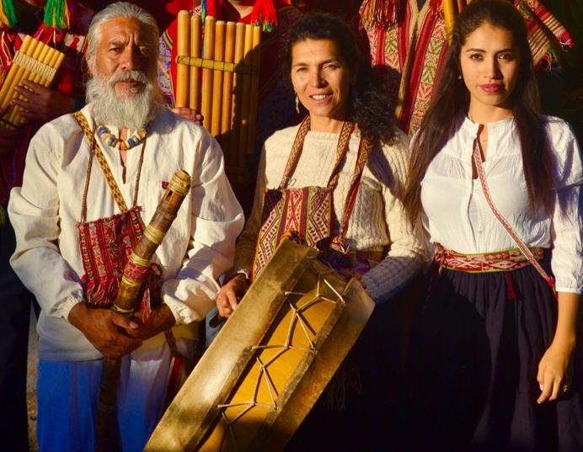

Today we will begin the day with a light breakfast in for our first encounter with Grand Father Wachuma in this sacred land of the Inkas, . We will be lead in Sacred Ceremony by the Ancient music of the Andes, while we open our hearts for healing to take place. This is a celebration of life and our existence, to give thanks for all of the knowledge and healing we received during our time in these sacred lands .through out the day we will be in nature exploring some ancient sites, meditating in each of them and connecting with great spirit through Grandfather Wachuma. Later in the day we will head to the train Station in Ollantaytambo to bejgin our Journey to Machu Picchu the crystal City of Light

Night at: Torre Inka or Salkantay
All Meals Included

Day 3: Machu Picchu Sunrise and Plant Medicine Ceremony (March 7th )
Sacred Sites activation
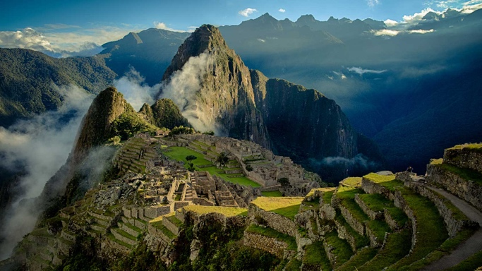
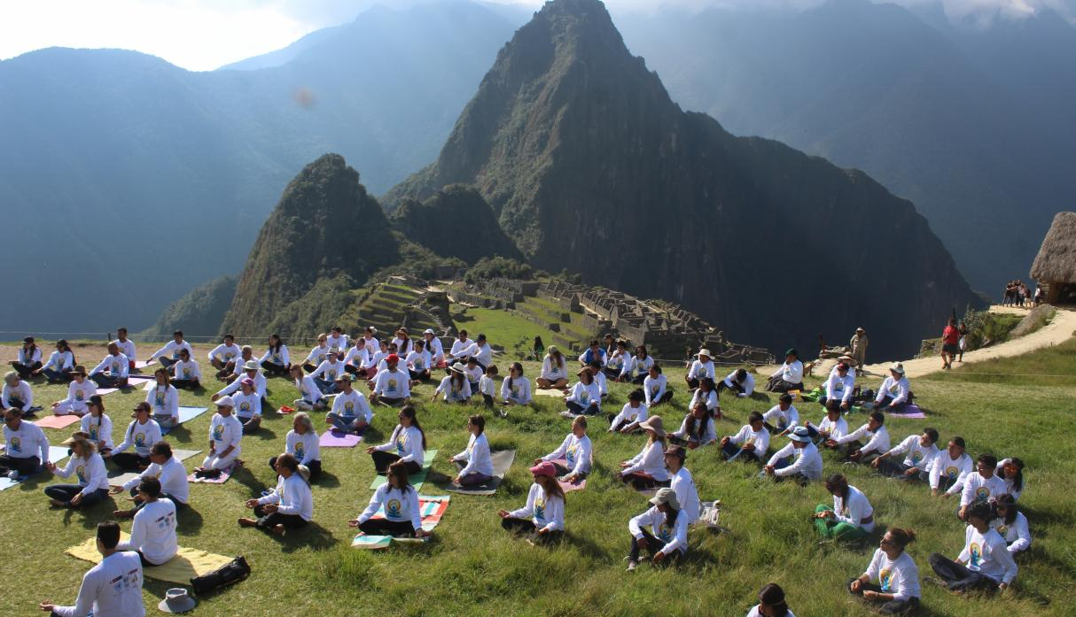

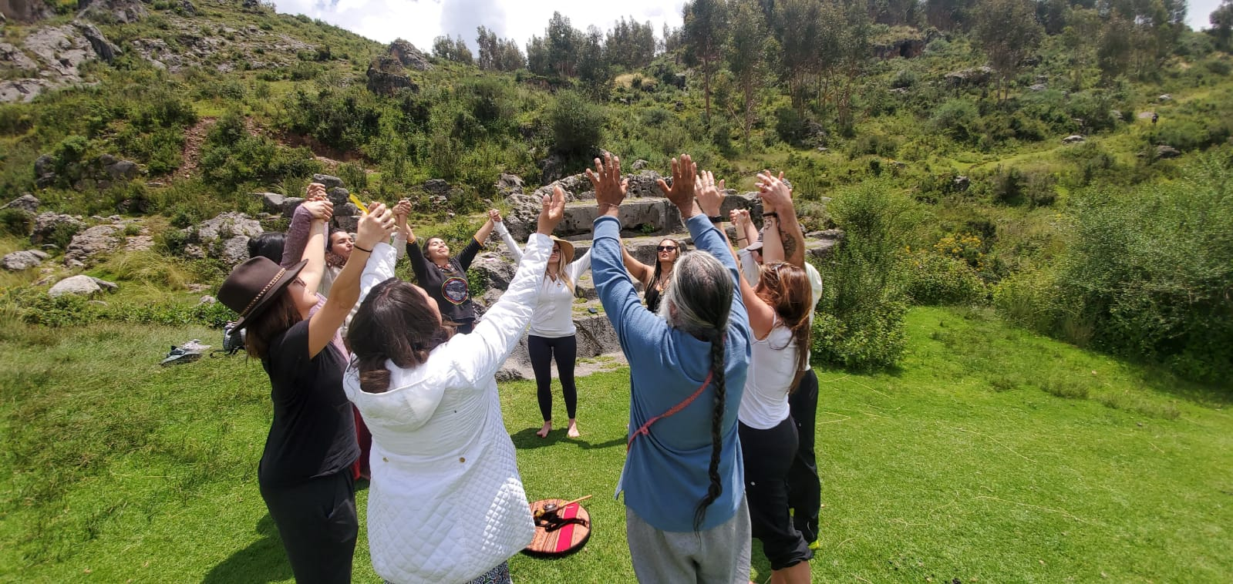

Today, we will be rising early to have our first encounter with Machu Piicchu, will begin with a meditation and connection with the energy of this crystal city with a sunrise ceremony in preparation for the highlight of the day which will be our Plant Medicine ceremony inside Machu Picchu, a very rare opportunity to sit in ceremony to open our hearts and achieve the transformation we seek. The san Pedro is a very mild medicine plant which we recommend do to the its peace full nature. This ceremony will be guided by our Spiritual guide Wachan will guide us through Machu Pichu to show us the most important temples and altars of Machupicchu as we are also guided by GrandFather Wachuma through the land Of the Inkas.
Night at: Torre Inka or Salkantay
All Meals Included

Day :4 Mandor Waterfall cleansing Ceremony , Plant Medicine Ceremony, Offering for mother Earth (March 8th )
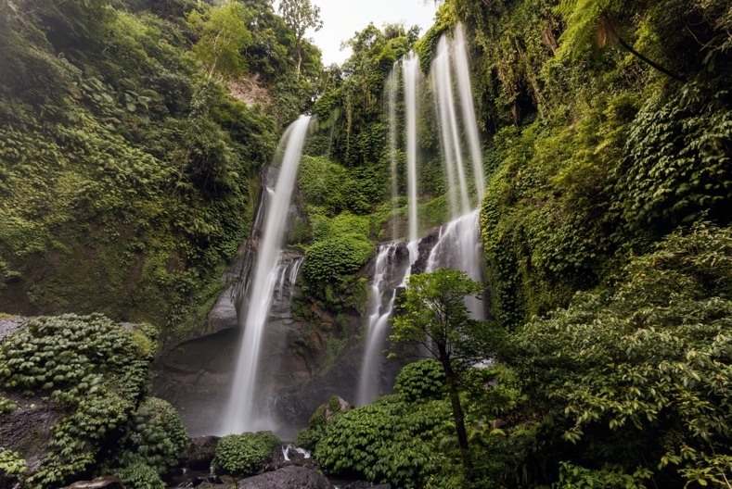
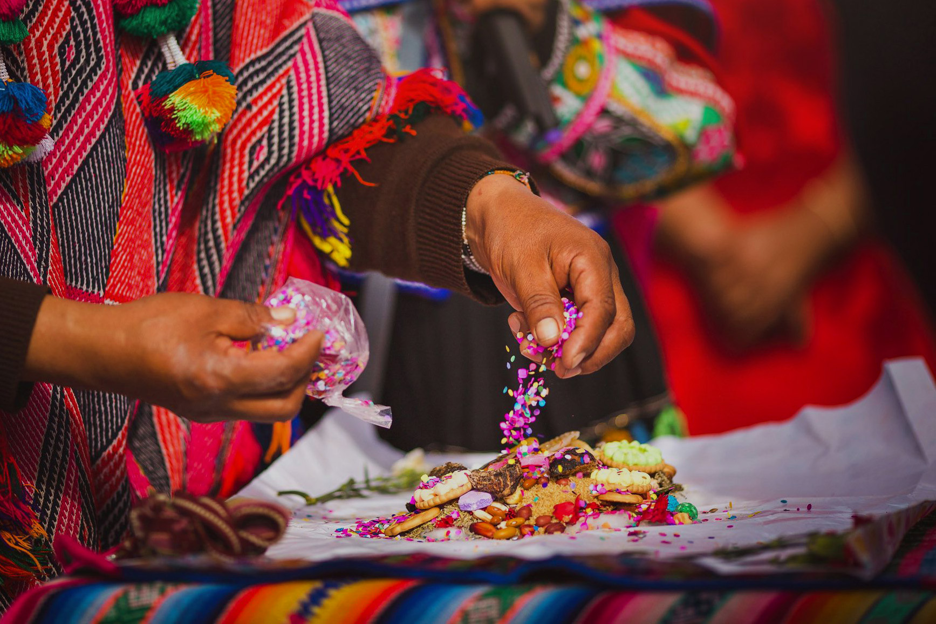
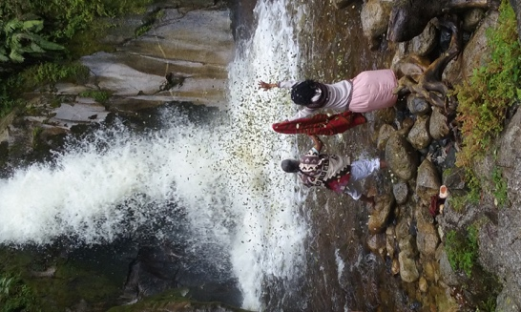

Today is a special day! We will go to the water falls of Mandor this is an amazing botanical garden with an extraordinary eco system we will walk for about 40 minutes to a magical garden where we will begin with a purifying ceremony with these scared waters, here we will sit in sacred ceremony with Grandfather Wachuma as we prepare a beautiful offering for mother Earth

Night at: Mandor Inn
All Meals Included

Day :5 Ayahuasca Ceremony, Purification ceremony, introduction to sacred plant medicine ( March 9th )
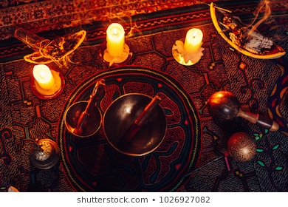
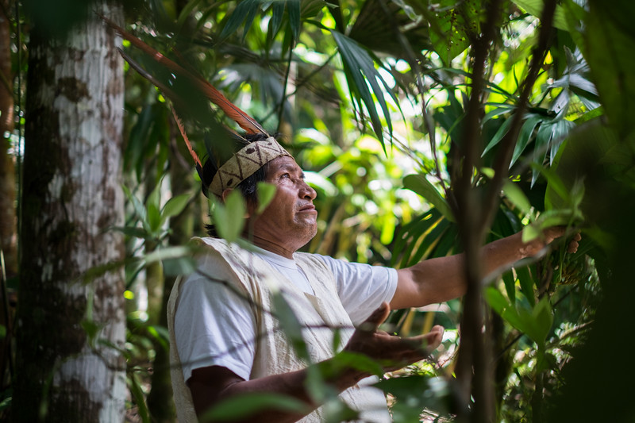

Today we will have out first Ayahuasca ceremony with Mother Plant Ayahuasca, a sacred time in which we will learn how to begin our self-teaching. We will also receive an incredibly beautiful healing with Don Alberto who is one of the most experienced and knowledgeable native healers. He knows an impressive number of medicinal and ceremonial plants native to the Amazon. These plants will also be used in a poultice and this ceremony will be accompanied by the sacred Ikaros sung by Don Alberto. This will help us to experience a unique and incredibly deep connection and integration with the energies of Mother Ayahuasca. This will help us to achieve a state of mental, physical and spiritual balance. These are very important steps in the preparation for the ceremony of the Mother Plant Ayahuasca (it’s important to mention prior to performing this sacred ceremony that all the ceremonies and the use of natural elements are part of the Amazon Culture, since for Don Alberto and his culture receiving the Mother Plant Ayahuasca is not just another everyday ritual but a once in a life time experience with great spirit!
Don Alberto manqueriapa is the head of the community of rosa huacaria in the manu jungle of the Machiguenga tribe.He has been working with the mother plant for more than 40 years, and has inhetited the healing knowledge of his parents who were known healers in the Machiguenga tribe. Thus he carries the mother plant in his roots, always working in connection with the 4 earth elements to guide participants in his ceremonies to balance The 4 levels of the body, mental, physical, emotional, spiritual and the duality of our masculine and feminine energies. The healing done with Don Alberto is very connected to his roots and ancestors. His work with the plant is based on working from the roots of each one of us to be able to clean our energy fields of negative energy and unbalanced frequencies in our body allowing us to return to our center with a sense of peace and love. Don Alberto works with a lot of respect and love towards the people who come to look for connection with the mother plant..

Night at: Willkasara Retreat Center
All Meals Included

Day :6 Integration Day at Tipon Closing ceremony (March 10th)

Today we will be in the Sacred Temple of the Water, Tipon, here we will share our experiences, resolve any questions, and integrate with all the healing and transformation that has taken place during these very special days. This is one of the most important steps of the retreat, here we really understand the messages that were given to us by the sacred plant medicines, byethe Sacred temples, and the powerful land. Later in the day we will have sacred music as we celebrate life and thank these special lands for all of the teachings. This will be followed by a pic nick and free time to wonder at your own pace through this magical temple.

- If you would like to have a private healing session with Wachan today is the perfect day to do it!
Please let us know in advance so every person can have the opportunity .

Night at: Willkasara Retreat Center
All Meals Included

Day :7 Return Home, Shaman’s Market (March 11th)

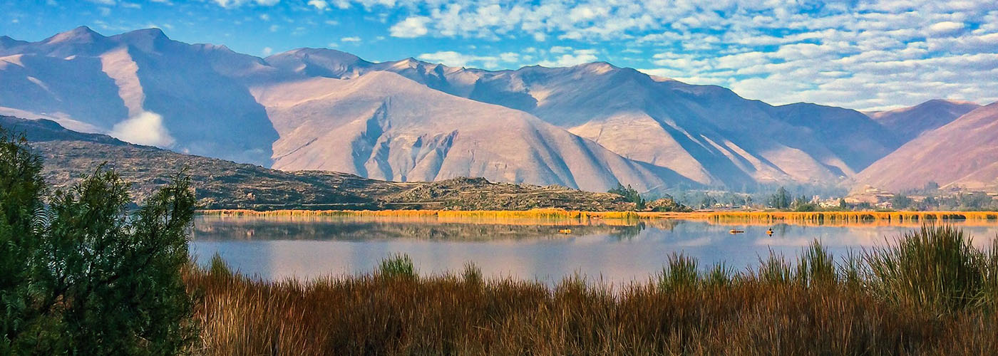

Today you will be heading home but before that, we will have the opportunity to have the very famous Shaman’s Market come to us for your safety. All of the items form the Shaman’s Market will be brought to the Retreat center: Drums, sacred incense, native jewelry, Shipibo weavings, painting, tabaco, medicine sticks, crystals, native clothing, rattles, instruments, and so many more special things all hand made by local artists. From here we will all be transported to the airport for your return home!
- there will only be one time of transfer to and from Airport for ALL passengers)

Meals Included: Breakfast, Lunch
End of Service

Retreat Details

Trip Cost Per Person:
$2,500 Single Occupancy Rooms During this retreat we will only have single rooms available
$2,450 Double Occupancy Rooms ( only those who have been together in the same living space for more than 2 weeks)

This unique Plant Medicine Intensive Includes :
- Entrances fees to all archeological sites included in the itinerary ( Please note that due to the pandemic many changes can occur with entrances to the archeological sites like Machu Picchu, Willkasara Sacred Expeditions and our representatives will not be liable for those changes )
- all Breakfasts
- all Lunches
- all Diners
- Train tickets to and from Machu Picchu
- Hotels and accommodations
- All ceremonies and teachings
- Ayni Pukara ceremony
- 3 Wachuma Plant Medicine Ceremonies
- 1 Ayahuasca Ceremonies
- Water purification Ceremony
- Machu Pichu sunrise ceremony
- Sound Healing
- Plant Medicine Introduction
- Introduction to the Andean ways of healing
- Ground transportation
- English speaking specialist guides
- Touring and excursions as per itinerary
- Airport arrival and departure transfer (there will only be one time of transfer to and from Airport for ALL passengers)
- ( Please note during these special times throughout the globe, the retreat itinerary is subject to changes)

Dose not INCLUDE :
- Domestic flight tickets
- Tips
- Personal expenses
- Private healing session
- Donations
- Meals not mentioned or indicated by tour facilitator

Requirements :
- Negative Corona Virus Test 7 days prior retreat departure
- Copy of Passport must be sent in order to book the retreat
- Obligatory use of KN95 facemasks, and gloves at all times during the retreat
( THIS MAY VARY DEPENDING ON NEW HEALTH INFORMATION BY THE RETERAT DATE )

Refund Information
- To Reserve your space on this retreat a 50% down payment is required.
- If you have to cancel your trip we must be notified by February 28th 2021, other wise No full or partial refunds will be made to you, no exceptions.
- Retreat must be paid in full by February 28th
During this crisis there are many additional restrictions in Machu Picchu and other Sacred sites, if because of the health crisis the group is not permitted in, there are No REFUNDS. If for some unexpected reason the entrance to Machu Picchu is not permitted we will continue in Mandor Water Falls)

Itinerary schedule is subject to changes at any time due to COVID-19

WILLKASARA SACRED EXPEDITIONS

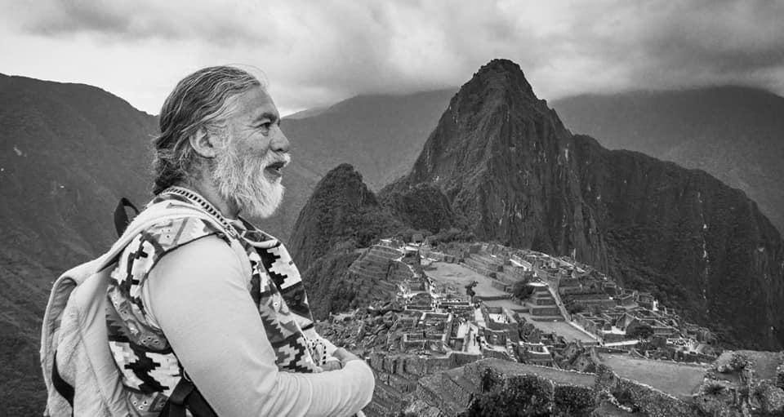

Our Spiritual guide Wachan Bajiyoperak
Wachan Bajiyoperak, born and raised in Cusco Peru comes form a lineage of Medicine People. His lineage is related to the Waro Panaca, a pre-Inka Society. He has received the teaching of both his Mother and father. His Mother was a gifted Midwife and skilled herbalist. Wachan's father was a very well known Chawpy Misa carrier ( Inka priest ) "I feel blessed to have been born in such a sacred land, and to have the privilege of caring on the ancient teachings and following the path of the ancient ones."

At the age of 7 Wachan's mother gifted him a Quena (Andean flute) to nourish his musical gifts. On day by the river side she gifted him this special flute saying " this will be your life long friend." within a few days Wachan was already playing the traditional songs his mother would sing daily. Form this day on Wachan began his journey as a Harawico which translates to Alchemist of Sound.

At the age of 7 this playful boy, Wachan would accidentally brake his flute, his loving mother would replace it with a new one every time it broke, until one day she stopped brining new flutes. This was the day that Wachan began building his own flutes. Since this day he has been building the traditional instruments of the Andes and studying the pre-Inka and Inka instruments.
​
In the 1980's Wachan and the Japanese icon Iso Tomita made a music video in the Nazca Lines of Peru, called " Song of the Universe " he later preformed in Japan with the ocarina Master, Sojiro in Japan. These was the beginning of Wachan's journey through the world sharing his music.

In the 1970's Wachan founded his first musical group " Apu Pachatusan" a cultural Group who's mission is to study, practice and keep the ancient heritage and ancient music alive.
​
Currently Wachan travels around the world, sharing the teaching of the ancient ones, through workshops, conferences, Plant Medicine Ceremonies, and spiritual retreats in the Andes of Peru .

Wachan considers himself a Harawico, which translates to Alchemist of Sound. He is a gifted Inka and pre-Inka instrument builder, composer and keeper of the sacred Andean Music . Wachan is a skilled sound therapist, herbalist and Plant Medicine facilitator, helping people reconnect with them selves, through Mother Earth, Pachamama.
​
Wachuma is cactus form the Andes of Peru that has been used by Inka and Pre-Inka Civilizations for thousands of years to rise the collective consciousness of our societies and to connect Mankind with the spirit world.
Grandfather Wachuma is the key to the heavens, and to reawaken the heart of mankind
This Sacred Plant Medicine reconnects you with the universal beauty, brings harmony, joy, peace and balance into our lives. Many people with depression, anxiety, drug and alcohol abuse have recovered fully through Wachuma Ceremonies.

Wachan has over 40 years of experience leading and facilitating Wachuma Plant Medicine Ceremonies around the world and helping many people recover of their ailments through his teachings and ceremonies.

"Our ceremonies are very sacred, we prepare ourselves during our whole life time for this path to be a keeper of the sacred Medicines. We respect life and the Sacred Medicines, we are not experimenting with people. In the last 20 years Wachuma and Ayahuasca have become very popular around the world because of their healing powers, at the same time this popularity has revealed a group of people from around the world who are confusing and misleading our ancient ways of ceremony that has been passed down generation after generation here in the Andes, claiming they are "shamans". These confused people are misusing the power of the sacred plants for their own greed. Love is not blind, love is wise.
My purpose and mission is to share with the world the magic and power of the Plant Medicine Wachuma in its authentic form in a safe and appropriate environment and to guide you into the magical and powerful land of the Andean Civilizations, Peru ."

Throughout the year, Wachan and his Family ( the Willkasara Medicine Family) travel around the world providing these teachings and ceremonies with those who are ready for transformation and healing, through seminars, workshops, retreats, sound healing, Plant Medicine Ceremonies, and healing session. At the end of the year the Willkasara Medicine Family co -facilitates a New Years silent meditation retreat with Rev. Micheal Bernard Beckwith to welcome the new year through meditation and Andean ceremonies.
We look forward to seeing you soon!

